Using Convex Optimization to Solve Image Processing Problems in Industrial Assembly Lines

Line 1: 1st Given Name Surname
Line 2: dept. name of organization
(of Affiliation)
Line 3: name of organization
(of Affiliation)
Line 4: City, Country
Line 5: email address or ORCID

Line 1: 2nd Given Name Surname
Line 2: dept. name of organization
(of Affiliation)
Line 3: name of organization
(of Affiliation)
Line 4: City, Country
Line 5: email address or ORCID

Abstract—This study focuses on addressing challenges in the detection of mechanical components in industrial assembly lines. The research goal is to achieve a high recognition rate for a particular type of mechanical component, an essential prerequisite for ensuring optimal performance of the assembly line. Both deep learning and convex optimization methods are applied in this study.
Keywords—Components; Industrial; Recognize; Convex

Introduction
In industrial assembly lines, it is increasingly crucial to ensure product quality, improve efficiency, and maintain safety. Besides, image processing remains to be a significant role in addressing these issues, compared to the traditional operating mode of being justified by human (Qu et al., 2008).
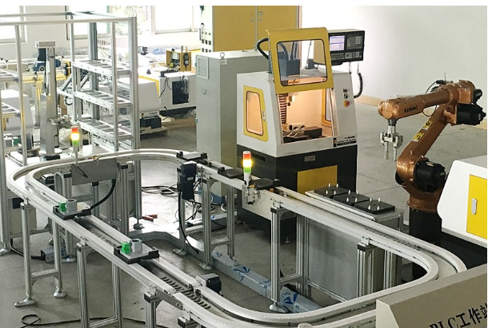
Fig.1 Example of Industrial Assembly Lines
In detail, the problem this report would like to solve comes to the recognition in mechanical component types detection. Specifically, it means that there are a bunch of mixed mechanical components which have different types and photos of them are taken. The mechanical components will be distinguished from the images. Next, it comes to combine these mechanical components into different storage compartments according to their types which display in the program (Lai et al., 2010).
In this study, the research goal turns to improve the recognition rate of the mechanical components classification under specific constrains.
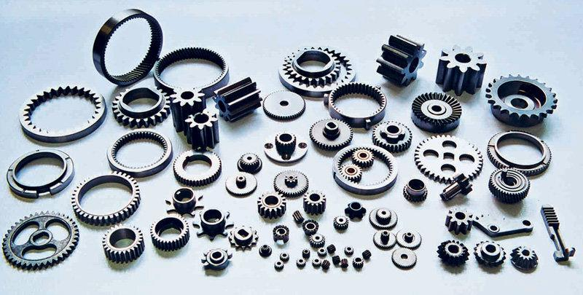
Fig.2 Example of Mixed Mechanical Components
In order to achieve the target, this work applies advanced image recognition algorithms. It not only enhances efficiency but also brings consistency in the quality of the products being manufactured, which leads to increased productivity and reduced waste. Moreover, the application of image processing in industrial assembly lines significantly reduces the dependency on human justification, thereby labor costs and human error get fewer. Additionally, it contributes to creating a safer working environment by minimizing the risk of accidents caused by manual sorting and handling of mechanical components.
This report discusses deep learning methods that can be used to solve the detection problem, common mathematical methods that may be involved, and comparing the effectiveness of combining convex optimization methods. In terms of theoretical foundation, adjusting parameters or formulas in a deep learning framework with convex optimization should achieve better results, which is more suitable for solving such problems in industry.

Literature Review
As mentioned in the introduction, the convenience of using artificial intelligence to solve detection problems in the industry has been discovered, and different methods have been applied. This review will serve as a comprehensive examination of the current state of knowledge on the subject, offering an overview of the most pertinent information sources (Wang & Lin, 2014).
The problem needed to solve can be viewed as a specific application scenario in object detection. Specifically, object detection refers to the process of accurately locating the position of an object in a given image and labeling the object's category.
Object detection means the current task of identifying objects in a graph while also using boxes to outline their positions. This task essentially aims to solve two issues. The first is image recognition, where the input is images, the output is categories, and the evaluation method is accuracy; The second comes to the object localization, with the input being an image and the output being the position of the box in the image (x, y, w, h), the evaluation method is to detect the intersection over union evaluation function. Thus, this study focuses on optimization lies in the first issue of image recognition.
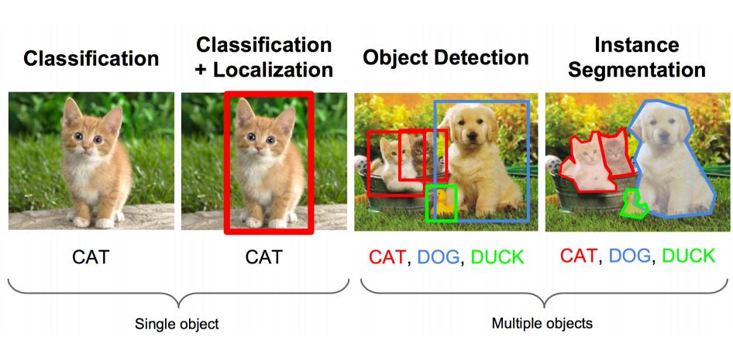
Fig.3 Example of Mixed Mechanical Components
In this report, current object detection algorithms are divided into two categories, entailing deep learning methods and mathemadical methods. By synthesizing this wealth of information, the review provides a solid foundation for further research and understanding of the topic.

Deep Learning Methods
Deep learning methods typically involve using candidate regions or windows, and apply deep learning frameworks for classification or regression as for the theoretical foundation.
- Steps in deep learning methods
Task | The Perspective of Theory
Steps | Using candidate regions/windows | Classification | Regression

The theory of deep learning frameworks related to object detection problems revolves around the use of neural networks to identify and classify objects within images or videos. The main aspects of this theory include:
- Convolutional Neural Networks (CNNs): These are a cornerstone in object detection tasks as they excel at extracting features from visual data. CNNs use filters to learn image characteristics such as edges, shapes, and textures, which is used to detect objects.
- Region Proposal Methods: Early deep learning-based object detection involved region proposal methods that first identified potential object locations (regions of interest) within an image before classifying them. Examples include Selective Search and EdgeBoxes.
- Anchor Boxes: Modern detection frameworks like Faster R-CNN and YOLO use anchor boxes and predefined reference boxes of various sizes and aspect ratios, so as to predict object boundaries and classes.
- One-Stage vs Two-Stage Detectors: Frameworks like YOLO represent one-stage detectors that directly outputs class probabilities and bounding box coordinates in a single pass, while two-stage detectors like Faster R-CNN first generate region proposals and then classify them.
- Loss Functions: Object detection models typically emploies specialized loss functions that account for classification accuracy, bounding box regression, and sometimes objectless scores.
Below is a comparison of the advantages and disadvantages of some popular deep learning object detection frameworks, including R-CNN, SPP-net, Fast R-CNN, and YOLO. Please note that these frameworks are continuously evolving with time and advancements in technology, so the information listed here may not include the latest improvements or variants.
- comparison in deep learning frameworks
Framework | Advantages | Disadvantages
R-CNN | First to propose deep learning for object detection, higher detection accuracy, good at handling overlapping objects | High computational cost, slow speed, requires a large amount of storage space, needs extensive disk space during training
SPP-net | Introduced spatial pyramid pooling, improved speed,  Can generate fixed-length feature vectors, accelerating processing,  Can handle images of different sizes | Limited improvement compared to R-CNN,  Still has high computational costs,  Both training and testing times are still long
Fast  R-CNN | Combines recognition and localization tasks with multi-task loss  Uses ROI pooling layer, significantly faster  Higher detection accuracy | High memory consumption  Training time is still quite long  Complex model structure, difficult to optimize
YOLO (You Only Look Once) | Real-time object detection, fast speed  Single-stage detection, streamlined process  Lower risk of overfitting  Suitable for running on resource-limited devices | Poorer detection accuracy for small objects  Localization precision not as good as two-stage models  Not very good at handling dense objects

Traditional Mathematical Methods
In these methods, usually there are three steps:
1) Image preprocessing and region selection (exhaustive strategy: using sliding windows with different sizes and aspect ratios to traverse images, high time complexity)
2) Feature extraction (SIFT, HOG, etc.; morphological diversity, lighting variation diversity, background diversity makes feature robustness poor)
3) Classifier classification (mainly including SVM, Adaboost, etc.).
- Steps in mathematical methods
Task | The Perspective of Theory
Steps | Image preprocessing and region selection | Feature extraction | Classifier classification

Image pre-processing and region selection are crucial steps in the computer vision pipeline, particularly for object detection tasks. What is more, it is performed on captured product images, noise-reducing and sharpening are performed after selecting effective regions for feature extraction. Normally, image preprocessing is used to improve the images quality and reduce noise that may affect the accuracy. On the other hand, noise reduction can remove unnecessary information from the image, and sharpening enhances the important information of the image. If the target object is concentrated at one area in the image, and the effective region can be located through the features of the concentrated area, it is better to select them first. Otherwise, region selection methods can be used. One of the region selection method is a sliding window mechanism, which symbolizes the scans of the images with small windows. and carry out exhaustion.
The following is feature extraction. To extract features, Scale-Invariant Feature Transform (SIFT) and Histogram of Oriented Gradients (HOG) can be used as well. After features have been extracted, it comes to classifer classification. Classifiers like Support Vector Machines (SVM) and Adaboost are common. SVMs can handle high-dimensional spaces and get optimal ways to separate different classes, whileadaboost works by combining weak classifiers to form a stronger classifier.
Traditional mathematical methods are difficult to achieve the results brought about by deep learning methods, but they still have learning and experimental value. They are the foundation of deep learning theory and have guiding significance in controlling details, such as adjusting parameters, understanding formulas in frameworks, and optimizing them.
It is argued that the methods mentioned above can achieve certain results, while there is still improving room. For instance, deep learning methods may have massive redundancy, and the mathematical methods may be not accurate enough (Becker et al., 2014).
When facing complex and multi-dimensional parameters in an assembly line, how to select appropriate data, how to construct suitable model and methods to optimize the goal under more restrictive conditions, and how to reach better recognition or quality control rates under stricter evaluation criteria should be further considered.

Convex Optimization Methods
Convex optimization also belongs to mathematical methods, which mainly deals with the minimization or maximization of convex functions. It has a very broad range of application scenarios. Below are some convex optimization theories:
- Gradient Descent: a method of alliteratively updating weight parameters using gradients to minimize the objective function.
- Newton's Method: It uses second-order derivatives (Hessian matrix) to find the minimum or maximum of a function, which is also known as the Newton Raphson method, is a method proposed by Newton in the 17th century for approximating equations in both real and complex fields. Most equations do not have a formula for finding roots, so it is very difficult to find the exact root, making it particularly important to find the approximate root of the equation. It uses second-order derivatives (Hessian matrix) so as to find the minimum or maximum of the function.
- Second-order Cone Programming (SOCP):An efficient nonlinear optimization method, in which the second-order cone is a special closed convex cone, which is mathematically defined as a set of inequality constraints with quadratic terms, which can be processed by using the interior point method
The application of convex optimization methods tends to be essential for optimizing the goal under stricter conditions.
All in all, the listed methods, models, frameworks or algorithms, all of them can provide a certain level of effectiveness, how to combine their advantages to discover more suitable methods for solving specific problems is more important.

problem FORMULATION
This study is designed to investigate if convex optimization methods can work in dealing with complex image-related challenges in industrial assembly lines. Since convex optimization methods are suitable to solve issues of finding the optimal value under certain constraints, the constraint that only the recognition rate of mechanical components having high weight (Hong et al., 2014) requires improvements are added.
The constraint of different mechanical compartments having different weight requirements means that in these mixed mechanical components, components of type A are more important than components of type B, so the research tries to improve the recognition rate of type A, but expects not to decrease the recognition rate of type B. This refers to the ideas of previous paper (Doherty et al., 2001). Through a diversified method, it is expected to improve the recognition rate of type A and get balancing performance.
Potentially, there is evidence to approve that our method has beneficial implications for handling problems which appear in practical industrial scenarios.
Moreover, comparing the effectiveness of convex optimization methods in solving the above-mentioned problems with deep learning and mathematical methods mentioned in the literature review, will be beneficial to facilitate a comprehensive understanding of the research problem at hand.
In addition, whether it can achieve better performance by combining the advantages of deep learning models and convex optimization methods is also under consideration and wants to be verified through experiments.

Methodology description
Upon the foregoing analysis, the study has successfully identified the crucial issue that requires resolution through text-based descriptions. Consequently, the research is to expound upon the methodology employed in conducting and designing the experimentation procedures to corroborate our proposed hypothesis. As corroborated by Ames et al. (2014), the significance of this approach cannot be overstated, as it provides a solid foundation for substantiating the innovative ideas.

Data Source
It involves searching for a comprehensive array of high-quality images of various mechanical components in their mixed states, as seen from the front perspective. The study purchased some mechanical components ourselves to conduct experiments and use devices such as mobile phones or cameras to take photos under good lighting conditions. By doing so, it ensures that there are sufficient and exclusive data sources.
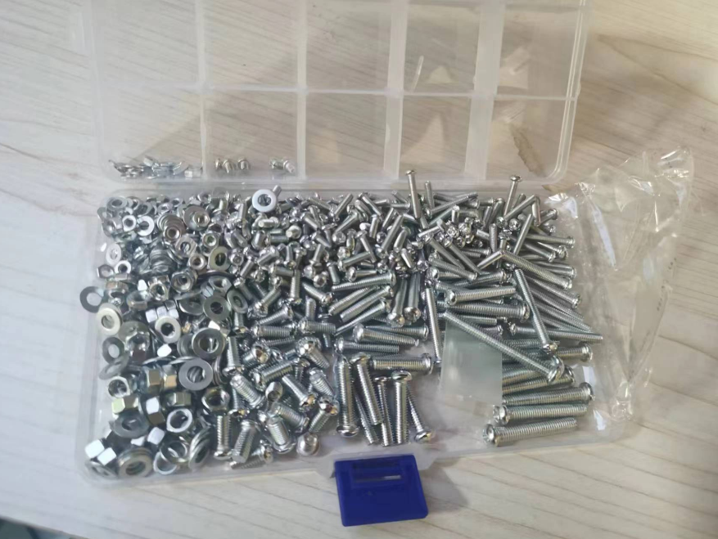
Fig.4 Data source

Applied Methods
The aforementioned sentence refers to the integration of various methodologies in a research project, with a particular focus on deep learning, mathematical approaches, and convex optimization techniques. For the sake of simplicity in description, deep learning and mathematical approaches will be mentioned as traditional methods, convex optimization method will be mentioned as our method.
- Deep Learning Methods
We choose fast R-CNN for it has proven superior performance and high-speed computing capabilities. The network architecture of Faster R-CNN consists of two main parts: a convolutional neural network (CNN) as a feature extractor, and a region proposal network (Rpn) for generating candidate target regions. It uses a shared convolutional layer to extract image features and a simple sliding window to search for regions.
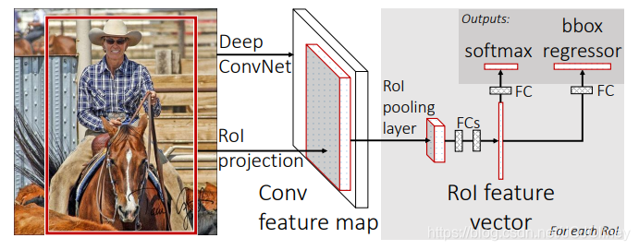
Fig.5 Network structure of fast-R-CNN
Specific practical steps of the deep learning method include selecting suitable frameworks, collecting data, making data annotations, training data to get the model, and using the model to get detection results although considered traditional, has seen significant advancements in recent years, particularly in the field of artificial intelligence. Steps in deep learning methods can be shown as belows.

Task | The Perspective of Practical Operation
Steps | Selecting suiltable frameworks | Collecting and annotating data | Getting and applying data

In deep learning methods, data can be annotated because it is helpful for the program or the system to understand the information. Then a deep learning model is used for training (Chuangdi & Zhixing, 2003). The importance of using correctly labeled data to train deep learning models and the influence it has on the performance of the system is easy to understand. The refinement in early data processing can bring great convenience to the improvement of subsequent detection accuracy.
Then, the accurate input of various data and the accurate setting of parameters ensure the correct operation of the framework and obtain a suitable model. Then, it comes to invoke the test set for testing and obtain a recognition accuracy rate result that meets the current standard of industrial objection detection as a benchmark.
- Traditional Mathematical Methods
The mathematical method, which is mentioned in the literature review, is also an essential part in this work. It is the theoretical foundation that for the deep learning method and convex optimization methods, offering mathematical basis for solving the problem. Scale-Invariant Feature Transform (SIFT) vs Histogram of Oriented Gradients (HOG) , and Support Vector Machines (SVM) vs Adaboost is combined to provide comparison result by using the same training data and testing data.
- Convex Optimization Methods
The convex optimization method is responsible for optimizing the parameters and optimizing local effects to ensure its efficiency. The convex optimization method itself can also be used for simple classification, and it will be directly applied to classify processed data, which provides another comparison result by applying the same training data and testing data as well.
- Deep Learning Methods with Convex Optimization
Convex optimization methods can also be applied to optimize the parameters of deep learning models, achieving the goal of combining convex optimization methods with deep learning models, which helps improve the effectiveness.
- Steps in proposed deep learning methods with Convex optimization
Task | The Perspective of Practical Operation
Steps | Selecting suitable frameworks | Optimizing through convex optimization | Collecting and annotating data | Getting and applying data

In summary, the combination of the methods of deep learning, mathematical, and convex optimization techniques, provides a comprehensive solution to address the proposed problem in multiple perspectives. In short, these solutions complement each other, reflecting that sufficient argumentation is conducted on this issue.

Practical Implications
It is acknowledged that the significance of the study lies not only in the accumulation of knowledge but also in its application. The very process of learning and verifying knowledge through practice enables to understand theoretical concepts more profoundly. This not only completes the problem discovery but also equips with skills required to tackle real issues.
It is expected that this study will prove beneficial in addressing similar problems in industry. The application of academic knowledge in practical scenarios fosters a synergy between theory and practice. To be specific, it contributes to the development of novel solutions and the enhancement of existing ones, thereby driving the progress of industry. Furthermore, it is crucial to appreciate that the practice of verifying knowledge through experiments.
This study tends to be a continuous process that sharpens the problem-solving skills and broadens the research perspective. All in all, this approach builds the bridge and fill in the gap between academia and industry, ensuring that the benefits of academic research are translated into real-world impact.

References

- Ames, Brendan P. W. , and S. A. Vavasis . "Convex optimization for the planted k-disjoint-clique problem." (2010).
- Cevher, V , S. Becker , and M. Schmidt . "Convex Optimization for Big Data: Scalable, randomized, and parallel algorithms for big data analytics." IEEE Signal Processing Magazine 31.5(2014):32-43.
- Chuangdi, Li , and L. Zhixing . "THE COMPLEX MODAL METHODS FOR ANALYSIS OF RANDOM EARTHQUAKE response OF STRUCTURES WITH TMD." Journal of Vibration and Shock (2003).
- Doherty, Lance , K. S. J. Pister , and L. E. Ghaoui . "Convex Optimization Methods for Sensor Node Position Estimation." Proc of IEEE Infocom Anchorage Alaska (2001).
- Hong, Mingyi , et al. "A Block Successive Upper Bound Minimization Method of Multipliers for Linearly Constrained Convex Optimization." Mathematics of Operations Research 45.3(2014).
- Lai, Hang Chin , and T. Y. Huang . "Complex analysis methods related an optimization problem with complex variables." European Journal of Pure and Applied Mathematics 3.6(2010):989-1005.
- Qu, Yi , et al. "Pattern Synthesis of Planar Antenna Array via Convex Optimization for Airborne Forward Looking Radar." ,84,(2008) 84(2008):1-10.
- Wang, P. W. , and C. J. Lin . "Iteration Complexity of Feasible Descent Methods for Convex Optimization." Journal of Machine Learning Research 15(2014):1523-1548.

